Test Case: tc002_SPX_Dev5_Crear_Requisicion_Spot_Con_FAD_Tipo_Cobro_CC
Step 1 - Enter username and password and click to button Enter : Credentials Entered
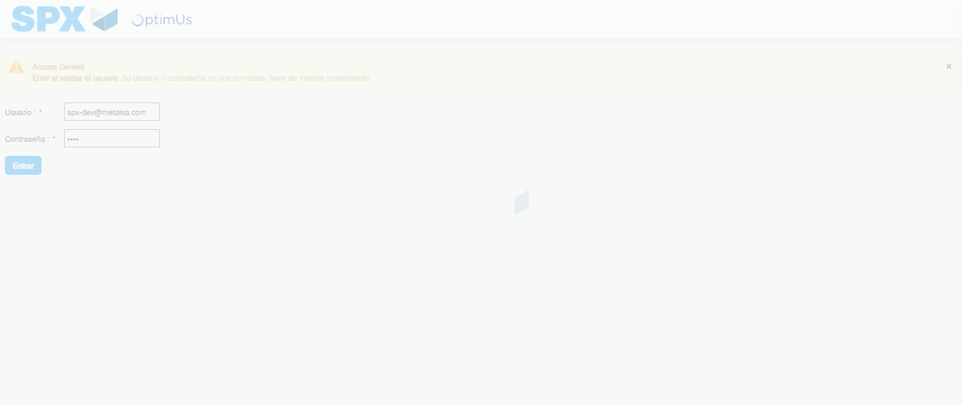Image file-name: QC_Testing-tc002_SPX_Dev5_Crear_Requisicion_Spot_Con_FAD_Tipo_Cobro_CC-1785343413901

Step 2 - Select to UEN and Access to Spot Buy Requisitions : UEN Correctly selected and Correct access
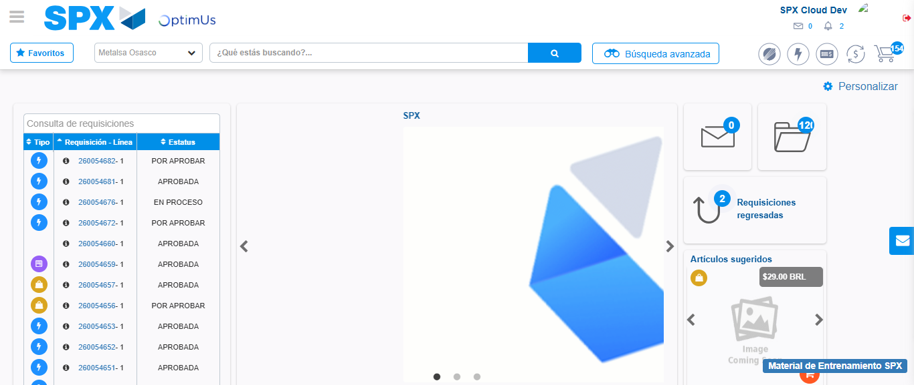Image file-name: QC_Testing-tc002_SPX_Dev5_Crear_Requisicion_Spot_Con_FAD_Tipo_Cobro_CC-1785343483561

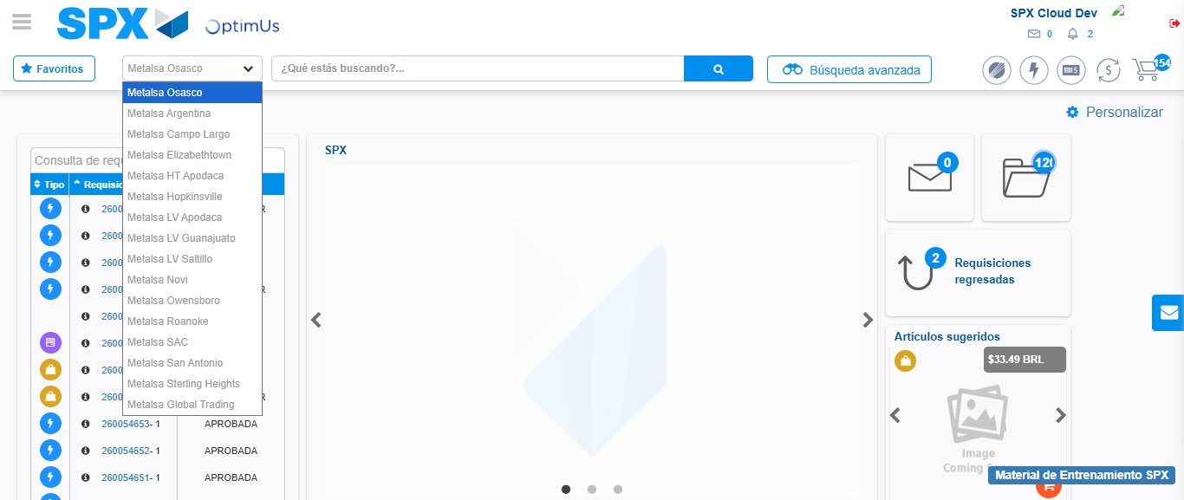Image file-name: QC_Testing-tc002_SPX_Dev5_Crear_Requisicion_Spot_Con_FAD_Tipo_Cobro_CC-1785343486098

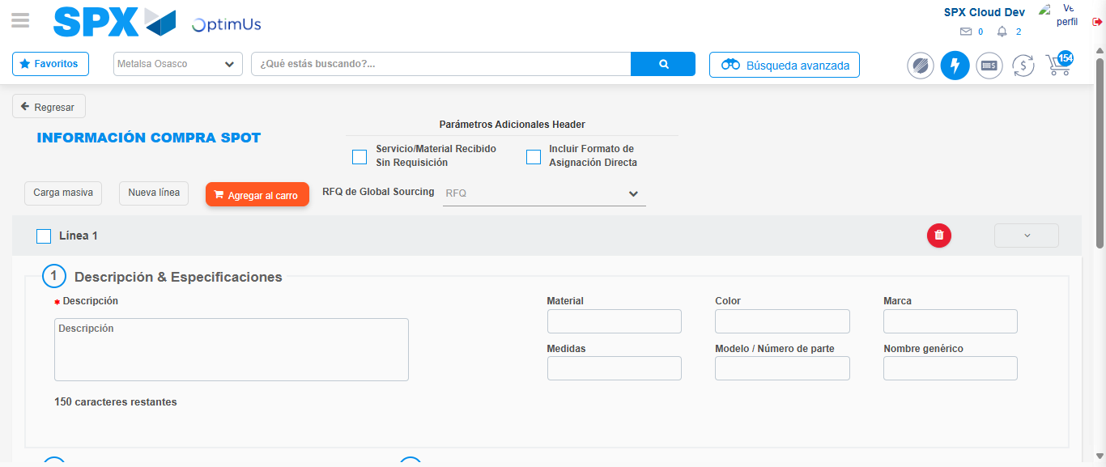Image file-name: QC_Testing-tc002_SPX_Dev5_Crear_Requisicion_Spot_Con_FAD_Tipo_Cobro_CC-1785343491553

Step 3 - Add FAD to Requisition: FAD Successfully Added
Image file-name: QC_Testing-tc002_SPX_Dev5_Crear_Requisicion_Spot_Con_FAD_Tipo_Cobro_CC-1785343491784

Image file-name: QC_Testing-tc002_SPX_Dev5_Crear_Requisicion_Spot_Con_FAD_Tipo_Cobro_CC-1785343491982

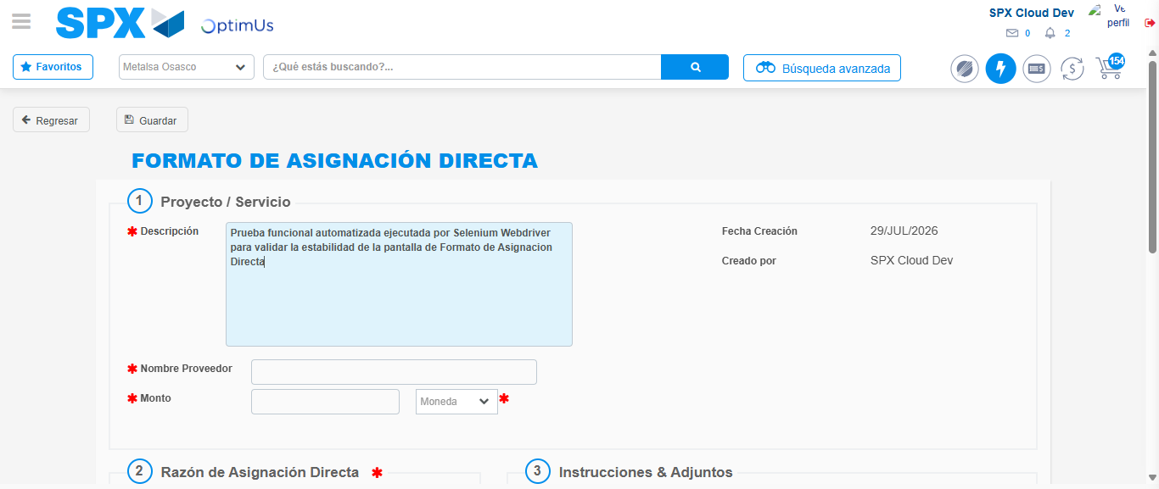Image file-name: QC_Testing-tc002_SPX_Dev5_Crear_Requisicion_Spot_Con_FAD_Tipo_Cobro_CC-1785343494701

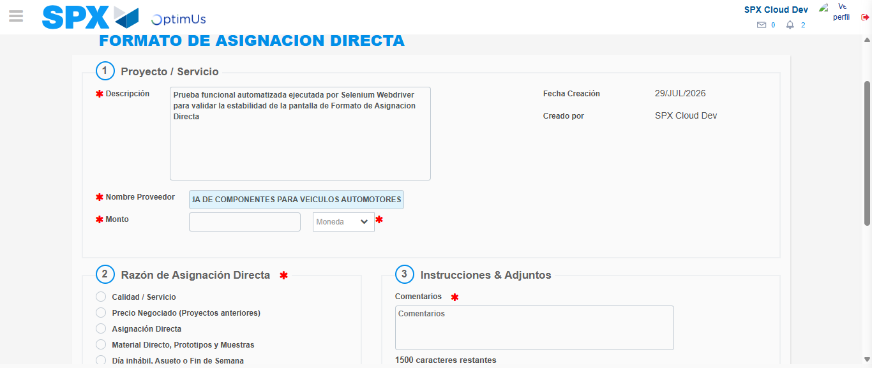Image file-name: QC_Testing-tc002_SPX_Dev5_Crear_Requisicion_Spot_Con_FAD_Tipo_Cobro_CC-1785343503639

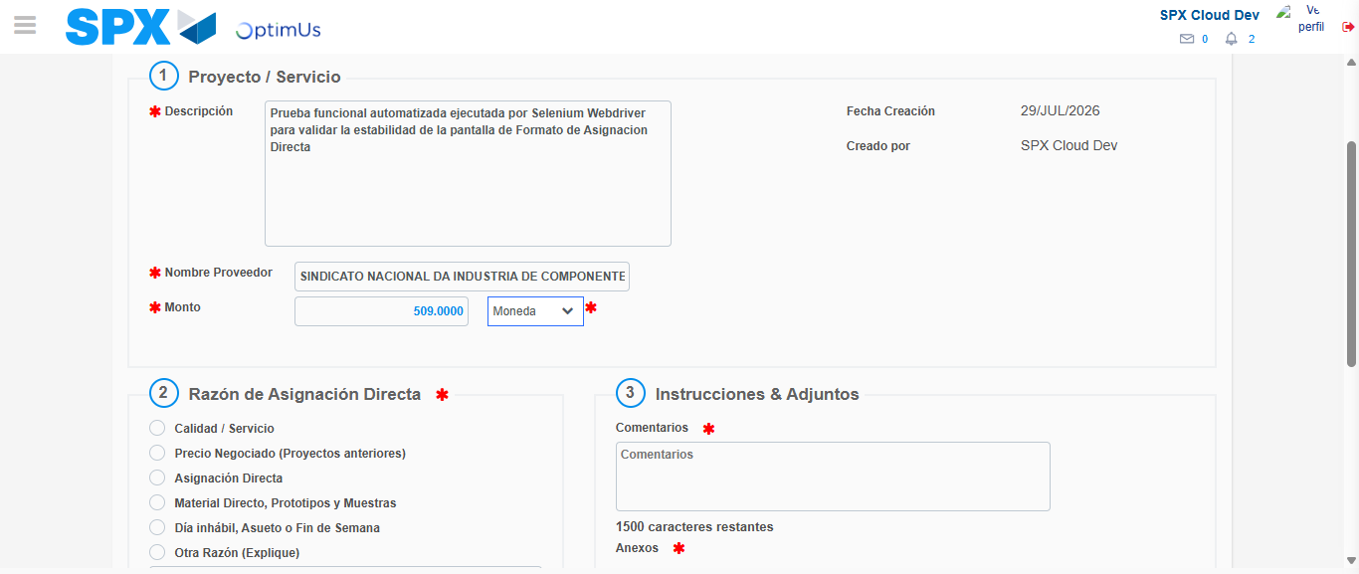Image file-name: QC_Testing-tc002_SPX_Dev5_Crear_Requisicion_Spot_Con_FAD_Tipo_Cobro_CC-1785343503976

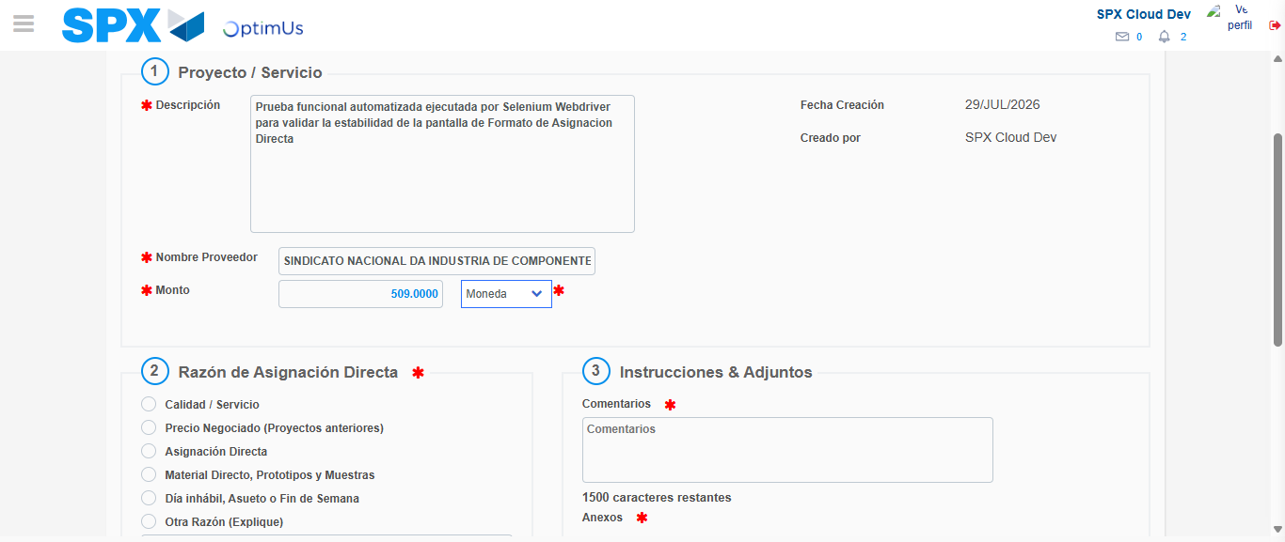Image file-name: QC_Testing-tc002_SPX_Dev5_Crear_Requisicion_Spot_Con_FAD_Tipo_Cobro_CC-1785343504169

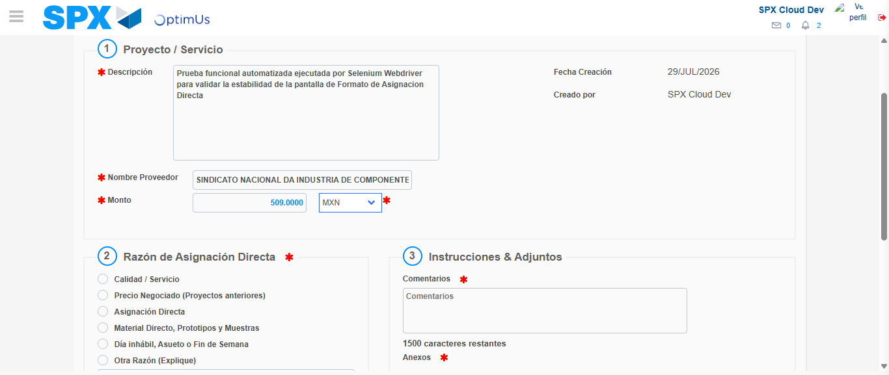Image file-name: QC_Testing-tc002_SPX_Dev5_Crear_Requisicion_Spot_Con_FAD_Tipo_Cobro_CC-1785343504506

Image file-name: QC_Testing-tc002_SPX_Dev5_Crear_Requisicion_Spot_Con_FAD_Tipo_Cobro_CC-1785343504681

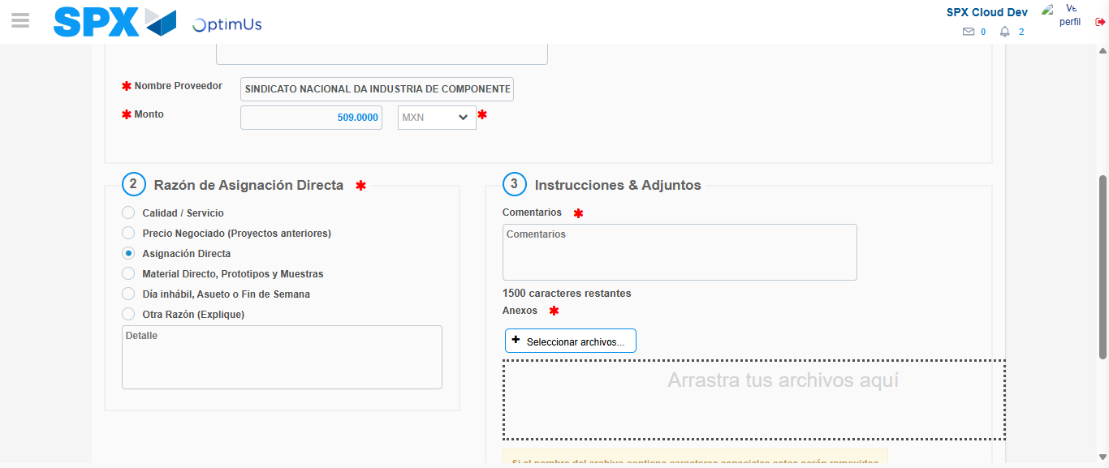Image file-name: QC_Testing-tc002_SPX_Dev5_Crear_Requisicion_Spot_Con_FAD_Tipo_Cobro_CC-1785343505474

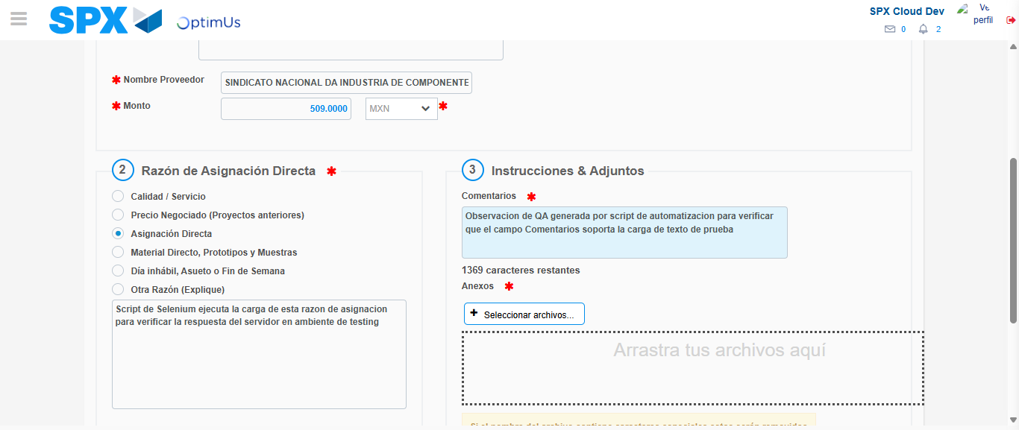Image file-name: QC_Testing-tc002_SPX_Dev5_Crear_Requisicion_Spot_Con_FAD_Tipo_Cobro_CC-1785343516481

Image file-name: QC_Testing-tc002_SPX_Dev5_Crear_Requisicion_Spot_Con_FAD_Tipo_Cobro_CC-1785343517192

Step 4 - Data Capture Spot Buy Requisition: Data captured correctly
Image file-name: QC_Testing-tc002_SPX_Dev5_Crear_Requisicion_Spot_Con_FAD_Tipo_Cobro_CC-1785343491784

Image file-name: QC_Testing-tc002_SPX_Dev5_Crear_Requisicion_Spot_Con_FAD_Tipo_Cobro_CC-1785343491982

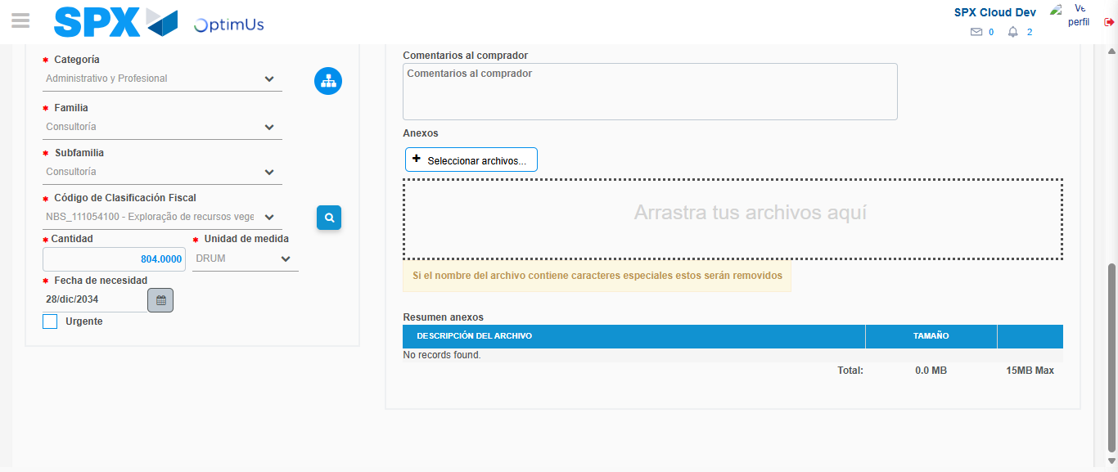Image file-name: QC_Testing-tc002_SPX_Dev5_Crear_Requisicion_Spot_Con_FAD_Tipo_Cobro_CC-1785343531476

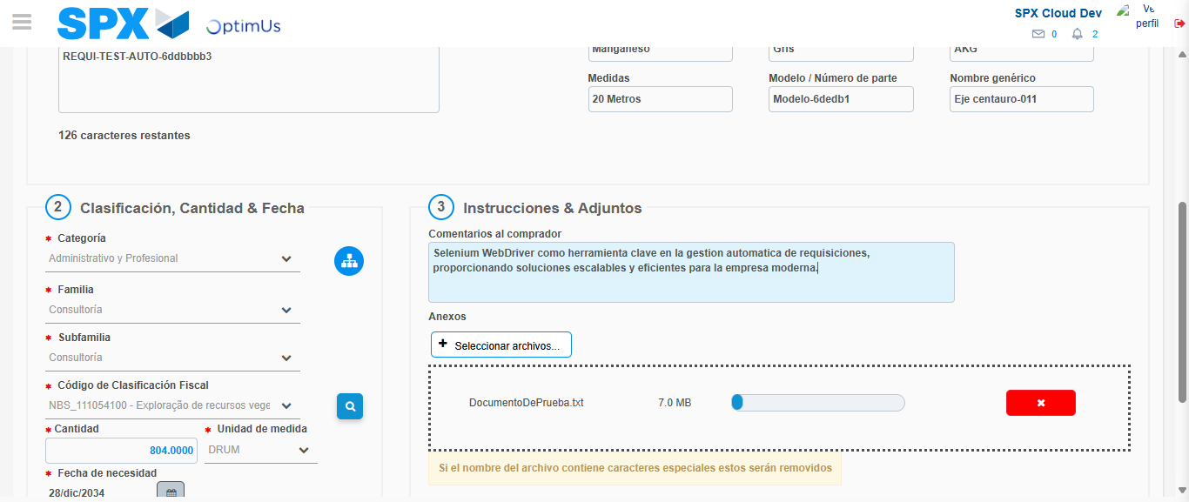Image file-name: QC_Testing-tc002_SPX_Dev5_Crear_Requisicion_Spot_Con_FAD_Tipo_Cobro_CC-1785343532262

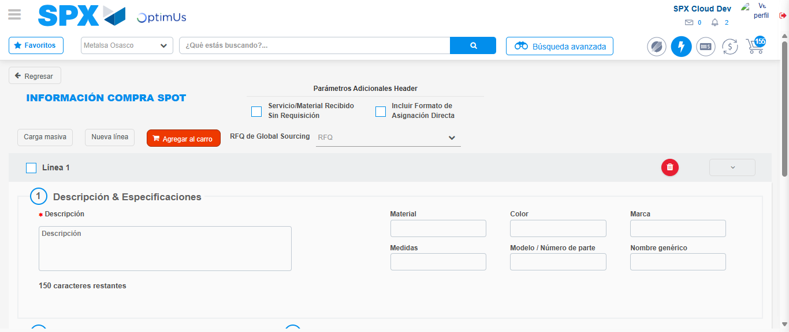Image file-name: QC_Testing-tc002_SPX_Dev5_Crear_Requisicion_Spot_Con_FAD_Tipo_Cobro_CC-1785343540620

Step 8 - Return to Main Page SPX : Return to Main Page SPX
Image file-name: QC_Testing-tc002_SPX_Dev5_Crear_Requisicion_Spot_Con_FAD_Tipo_Cobro_CC-1785343483561

Image file-name: QC_Testing-tc002_SPX_Dev5_Crear_Requisicion_Spot_Con_FAD_Tipo_Cobro_CC-1785343486098

Image file-name: QC_Testing-tc002_SPX_Dev5_Crear_Requisicion_Spot_Con_FAD_Tipo_Cobro_CC-1785343491553

Image file-name: QC_Testing-tc002_SPX_Dev5_Crear_Requisicion_Spot_Con_FAD_Tipo_Cobro_CC-1785343542852

Image file-name: QC_Testing-tc002_SPX_Dev5_Crear_Requisicion_Spot_Con_FAD_Tipo_Cobro_CC-1785343543020

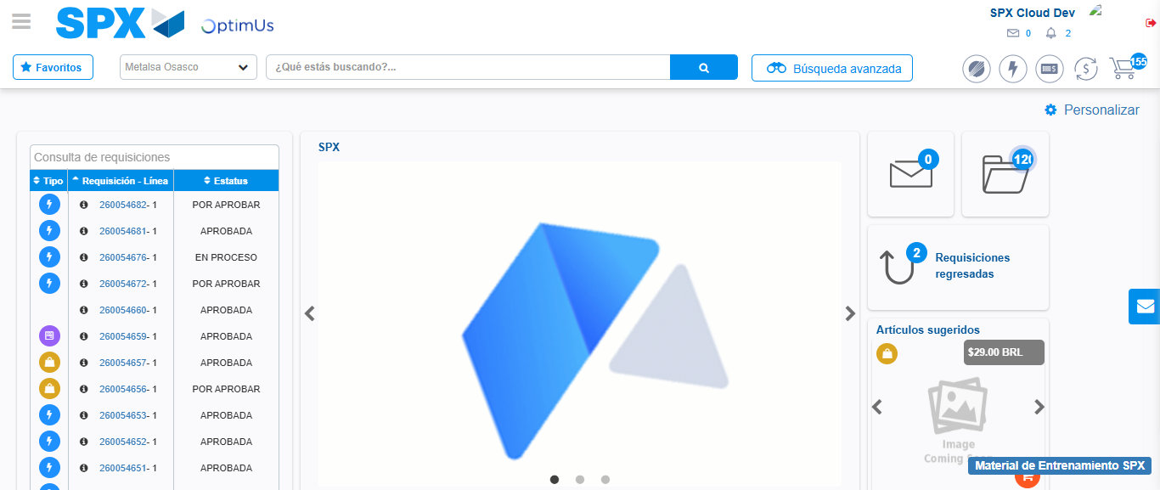Image file-name: QC_Testing-tc002_SPX_Dev5_Crear_Requisicion_Spot_Con_FAD_Tipo_Cobro_CC-1785343564059

Step 9 - Log Out : Log Out SPX
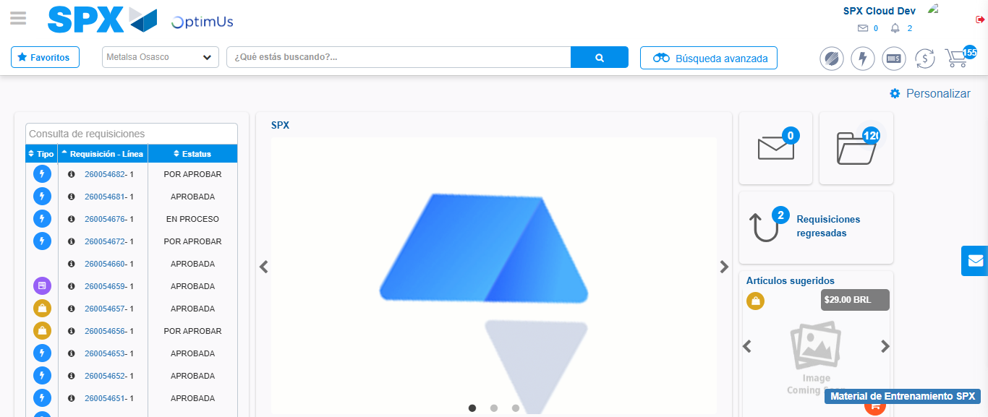Image file-name: QC_Testing-tc002_SPX_Dev5_Crear_Requisicion_Spot_Con_FAD_Tipo_Cobro_CC-1785343564346

